**Project Initialization and Planning Phase**

| Date | 15 March 2024 |
| --- | --- |
| Team ID | 740139 |
| Project Name | Acoustic Fire Extinguishing Prediction |
| Maximum Marks | 3 Marks |

### 

### Define Problem Statements ( Customer problem statementTemplate):

These problem statements highlight the critical issues and emotions experienced by the stakeholders involved in acoustic fire extinguishing, guiding the development of targeted solutions to meet their specific needs and concerns.

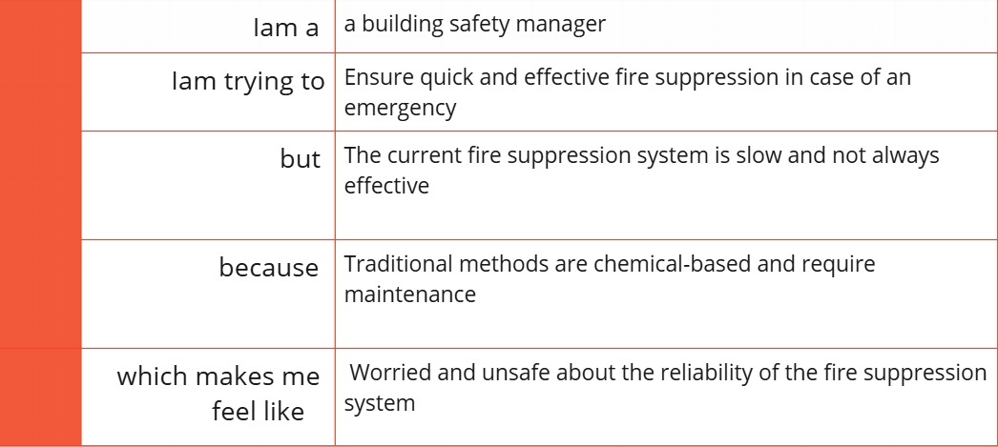

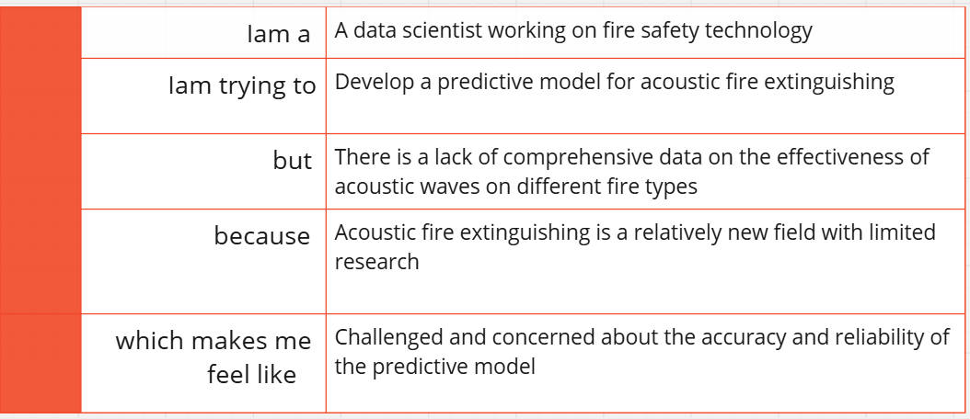

Reference: <https://miro.com/templates/customer-problem-statement/>

**Example:**

|  |  |  |  |  |  |
| --- | --- | --- | --- | --- | --- |
| **Problem**  **Statement (PS)** | **I am**  **(Customer)** | **I’m trying to** | **But** | **Because** | **Which makes me feel** |
| PS-1 | A building safety manager | Ensure quick and effective fire suppression in case of an emergency | The current fire suppression system is slow and not always effective | Traditional methods are chemical-based, require regular maintenance, and can be harmful to the environment | Worried and unsafe about the reliability and environmental impact of the fire suppression system |
| PS-2 | A data scientist working on fire safety technology | Develop a predictive model for acoustic fire extinguishing | There is a lack of comprehensive data on the effectiveness of acoustic waves on different fire types | Acoustic fire extinguishing is a relatively new field with limited research and standardized methodologies | Challenged and concerned about the accuracy, reliability, and validation of the predictive model |